**PROJECT PROPOSAL**

**Flash - Local Express**

*Adoption of Cloud Computing in the Industry*

Instructor:

**Mayra Samaniego MSc. Ph.D. (c)**

Members:

**Hai Nam Nguyen – 000520322 – nguyen0465@saskpolytech.ca**

**Cong Chi Tai Nguyen - 000516006 - nguyen6169@saskpolytech.ca**

**Xuan Hieu Nguyen – 000518043 – nguyen8191@saskpolytech.ca**

Table of Contents

1. Introduction 3

1.1. Abstract 3

1.2. Area of Research 3

1.3. Description of the Problems 4

1.4. Impact of Study 4

1.5. Accomplishment 4

2. Objectives 5

3. Research Plan 5

4. Project deliverables 7

5. Timeline 7

6. Budget 8

7. Conclusions 10

References 10

Appendix I 11

# Introduction

## Abstract

Our project is oriented toward local restaurants that are limited to online orders through the phone or website. All restaurants in Saskatchewan have chosen a third-party application for online orders, including payment and delivery. However, they abandoned a traditional sales channel, which also required a delivery force separately for a confirmed time from customers. For each order, the server records requirements from customers in a simple bill, which can be separated into two parts transferred to the kitchen and tracked at the end of the day. For this reason, there are many potential problems, such as handwriting mistakes, revenue statistics errors, lack of drivers, late delivery, etc., due to manual working. By using AWS services as a supporting platform, our intention aims to create an application assisting control food order efficiently and solving deficiency of drivers in the delivery stage. Our application makes all stages easier than ever by multi-state order management, which provides real-time status updating from initiation to delivery, ensuring optimal control and coordination. Both restaurants and customers receive instant notifications and updates, enhancing communication and reducing uncertainty. By offering a dedicated platform for local restaurant deliveries, the app minimizes reliance on external delivery services, resulting in cost savings and increased control over the delivery process as well as creating more jobs for the workforce.

## Area of Research

Based on obtaining information from the owner of Vietnamese restaurants in the [Appendix I], we have a deeper comprehension of the difficulties that these businesses have. By this way, research scope will be shortened in the following main points.

* Firstly, we are going to enhance delivery services for local restaurants. For more detail, it aims to strengthen channels of communication, improve delivery precision, and improve the overall operation of restaurants.
* Secondly, this project dives deeper into the possible advantages that may arise from the implementation of cloud computing for delivery management.
* Lastly, we will examine which benefits local food delivery may bring or effect on employment and the economy.

## Description of the Problems

In the appendix, it provided some specified difficulties faced by local establishments. The first disadvantage comes from **Manual Order Processing** including errors in handwriting and revenue data, which can lead to inaccuracies in order records. Furthermore, there are issues related to a **driver shortage**, which causes delays in the delivery process and impact on customer’s dining experience. It may cause complaints or bad ratings affecting the restaurant's reputation. Besides that, **dependent on Third-Party applications for online order and delivery** is the main reason for abandonment of traditional sale channels via phone, website, email. Last but not least, local restaurants should analyze the costs associated with food order application and explore potential savings from switching to an internal delivery application to mitigate **cost challenges**.

## Impact of Study

In the context of cloud-based solutions in restaurant management, there is a significant opportunity to encourage widespread adoption of cloud services among businesses. This can lead to improvements in scalability, security, and efficiency. Additionally, integrating technology in the form of cloud services can play a vital role in contributing to local economic growth by supporting businesses. By utilizing and facilitating technology adoption, especially through the implementation of a CI/CD pipeline, there is also a chance to demonstrate the importance of automation and continuous delivery in the software development life cycle. Furthermore, the findings, methods, and lessons learned from this project can contribute to academic research in various fields such as technology adoption, cloud computing, and user experience design.

## Accomplishment

To ensure the timely and accurate completion of this project, the most important factor is effective collaboration among team members to resolve any issues and establish a Continuous Integration/Continuous Deployment process (CI/CD) for a streamlined development process. Additionally, effective adoption of AWS services, including EC2, S3, RDS, VPC, IAM, ECS, CodeCommit, and CodePipeline in accordance with project requirements is essential. Finally, a continuous commitment to enhancing technical skills related to AWS services, cloud computing, and application development will further contribute to the overall success of the project.

# Objectives

The project aims to achieve two main objectives:

* + Implement a web application using Amazon Web Services (AWS)
  + Enhance the delivery process to empower restaurant owners in effective management.

# Research Plan

We have conducted an analysis of potential technologies based on factors like performance, security, and ease of integration with AWS services [1]:

* + Route53 is a scalable Domain Name System (DNS) to register DNS of our domain name.
  + CloudFront is a content delivery network (CDN) service for fast and secure content delivery globally.
  + S3 for scalable and secure frontend hosting, providing scalable compute capacity based on demand and will be used for secure and efficient storage such as images.
  + RDS as a managed relational database service, will handle the storage and retrieval of structured data related to delivery information.
  + ECS will be utilized for containerized backend deployment.
  + VPC allowing for a private and isolated network environment.
  + IAM will be implemented to manage user access securely, controlling permissions and roles within the application.
  + CodeCommit will be used as a fully managed source control service to securely store and manage application source code.
  + CodePipeline will be implemented to automate the build, test, and deployment phases of the application development process.

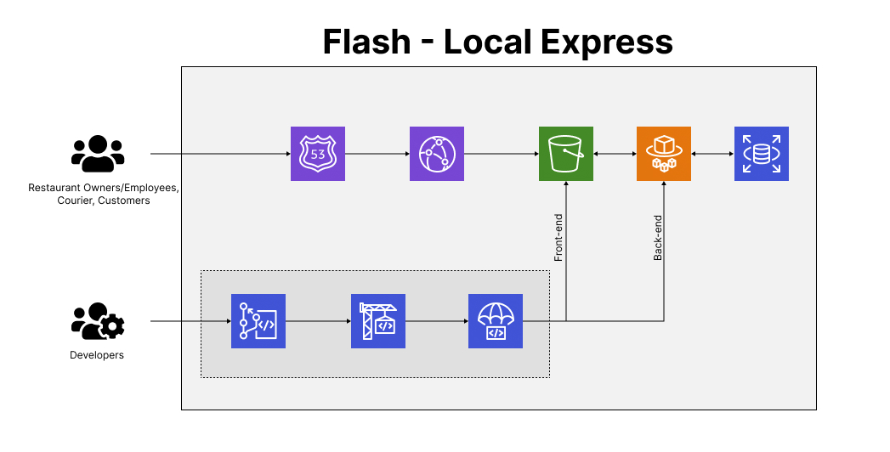

*Figure 1: Flash – Local Express - Architecture*

In our design and implementation plans, we prioritize effective knowledge sharing through the use of AWS documentation and follow best practices. Our data management strategy includes identifying data requirements, defining database schema, and implementing backup and recovery processes. By apply AWS ECS, we deploy Docker containers and orchestrate deployments. For the Continuous Integration and Deployment (CI/CD) approach, we use AWS CodeCommit for source control and AWS CodePipeline for automated builds and deployments. To ensure security measures, we utilize IAM role configuration and comply with AWS security best practices. Finally, for monitoring and logging, we use AWS CloudWatch, which enables real-time monitoring, logging, and custom alerting for proactive management.

More about our data management plan, Amazon RDS supports protecting the data through automatic backups, which create snapshots of entire database at scheduled backup intervals. This allows easy recovery to any point in time within the specified backup retention period, ensuring data integrity and security [2, p 947]:

*"Amazon RDS creates and saves automated backups of your DB instance or multi-AZ DB cluster during the backup window of your DB instance. RDS creates a storage volume snapshot of your DB instance, backing up the entire DB instance and not just individual databases. RDS saves the automated backups of your DB instance according to the backup retention period that you specify. If necessary, you can recover your DB instance to any point in time during the backup retention period."*

# Project deliverables

* + AWS Infrastructure setup
  + Application source code

# Timeline

In this proposal, we present a detailed timeline for tasks and activities required for the successful completion of the project. The roadmap below describes our project's timeline period from January 1st to April 1st, 2024, and utilizes the Jira Roadmap Planner [3] to demonstrate it.

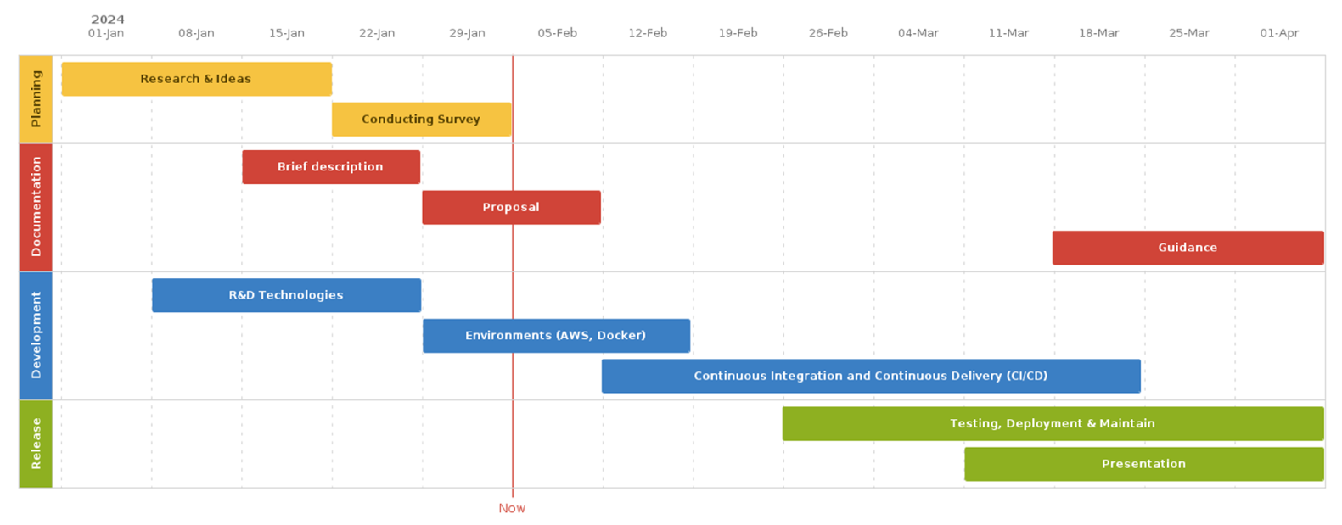*Figure 2: Flash - Local Express - Timeline*

There are 4 lanes which overlap with each other and start in parallel:

* Planning: This phase is mandatory for this project and must start from day 1 to gather information and initiate everything.
* Documentation: This phase is important for funding, approval, and documenting how this project works.
* Development: This phase implements and completes tasks related to the technical side.
* Release: One of the most important phases is this, which could be used for the later stages of this project.

In each lane, we have detailed tasks which can be clarified and explained below:

* Research & Ideas: The team must use up to 3 weeks to find out what needs to be done, why it must be done, and how to solve the issues, from January 1st to January 16th, 2024.
* R&D Technologies: Research and Development of the technologies that the team is familiar with and comfortable using for this project, from January 8th to January 22nd, 2024.
* Brief Description: Short and brief information about the project that could be used for the 30-second evaluator pitch, from January 15th to January 29th, 2024.
* Proposal: A complete documentation to propose to get approval and funding for this project, from January 29th to February 12th, 2024.
* Environments (AWS, Docker): The team needs a range of time to work with the environments for this project on Amazon Web Services and Docker, from January 29th to February 19th, 2024.
* Continuous Integration and Continuous Delivery (CI/CD): In this phase, we focus on planning tasks, coding, delivering, and deploying frequently using the Scrum Framework, one of the Agile Methodologies to execute it.
* Testing, Deployment & Maintenance: At this stage of the project, the team will deploy it to a production environment and test it simultaneously. They will gather feedback from the Owners/Servers of Restaurants and the couriers who deliver the food for them.
* Presentation: We also plan time for the presentation for this project not only in ABC talk but also in the Applied Research and Innovation [4].
* Guidance: The team will write documentation references for users who will use this web application.

# Budget

The project has a budget of up to $150, which can be used over four months. Details of each section are provided in the table below:

|  |  |  |  |  |  |
| --- | --- | --- | --- | --- | --- |
| **#** | **Service Name** | **February** | **March** | **April** | **May** |
| 1 | Domain .com | $12.00 | $0.00 | $0.00 | $0.00 |
| 2 | Front-end Theme | $32.00 | $0.00 | $0.00 | $0.00 |
| 3 | S3 Standard | $1.00 | $1.00 | $1.00 | $1.00 |
| 4 | Amazon RDS for PostgreSQL | $13.43 | $13.43 | $13.43 | $13.43 |
| 5 | AWS Fargate | $8.38 | $8.38 | $8.38 | $8.38 |
| **Cost per month** | | **$66.81** | **$22.81** | **$22.81** | **$22.81** |
| **Cost in 4 months** | | **$135.24** | | | |

*Table 1: Flash – Local Express - Budget*

We decided to allocate $50 for the domain and front-end theme, which can be purchased via Cloudflare [5] and Themeforest [6]. For the remaining services on Amazon Web Services, such as S3 Standard to store the front-end code, Amazon RDS for PostgreSQL, and AWS Fargate, we will utilize the $100 credit from the AWS Academy Lab Project - Cloud Web Application Builder course [7].

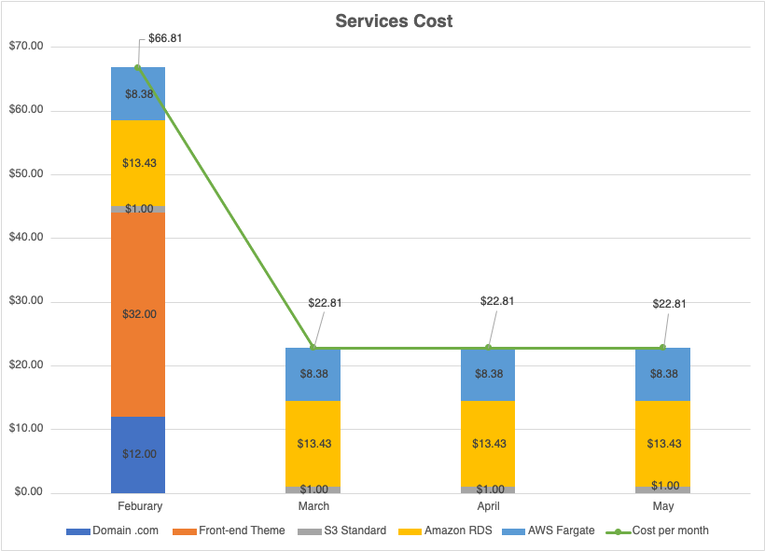

*Figure 3: Flash – Express Local – Budget bar chart*

The initial cost will be the largest for the domain and front-end theme, $12 and $32 respectively, payable one time only. There are some AWS service fees that can be calculated using the AWS Pricing Calculator [8], and these should be fixed costs for every month. At the end of the project, we will assess whether the project could be funded in May by Applied Research and Innovation. We will then decide whether to continue or shut down the project.

# Conclusions

In conclusion, our proposed web application aims to enable the learning of AWS services while enhancing the delivery process for local restaurants. By modernizing traditional delivery methods, we seek to optimize operations and improve efficiency.

# References

* How to Create a Project Proposal, ProjectManager.com, Apr. 24, 2023. [Online]. Available: <https://www.projectmanager.com/blog/how-to-create-a-project-proposal>
* [1] AWS Cloud products, Amazon Web Services, 2019. [Online]. Available: <https://aws.amazon.com/products/>
* [2] Amazon, "Working with backups," in *Amazon Relational Database Service: User Guide*, Amazon Web Services, 2024
* [3] Roadmap Planner Macro, Confluence Documentation, May 20, 2020. [Online]. Available: <https://confluence.atlassian.com/doc/roadmap-planner-macro-704578202.html>
* [4] Applied Research and Innovation, saskpolytech.ca, Feb. 07, 2024. [Online]. Available: <https://saskpolytech.ca/about/applied-research-and-innovation/>
* [5] Cloud Flare Registrar, Cloud Flare, Feb. 07, 2024. [Online]. Available: <https://www.cloudflare.com/products/registrar/>
* [6] Crema - React Admin Template Material Design and Ant Design (Nextjs-14+CRA-5), Themeforest.net, Feb. 07, 2024. [Online]. Available: <https://themeforest.net/item/crema/26540158>
* [7] AWS Academy, aws.amazon.com, Feb. 07, 2024. [Online]. Available: <https://aws.amazon.com/training/awsacademy/>
* [8] AWS Pricing Calculator, calculator.aws, Feb. 07, 2024. [Online]. Available: <https://calculator.aws/#/>

# Appendix I

We used Google Form: <https://forms.gle/JEJPosJgPansRqi58> to collect opinions from several local restaurants, here is the list we get survey:

|  |
| --- |
| Restaurant name |
| Restaurant 224 |
| Thien Vietnam 1 - Downtown |
| Thien Vietnam 2 - 8th street |
| Thien Vietnam 3 - Circle Drive |
| Summer Rolls |
| Chianti Cafe & Restaurant |
| Fuh Station 2 - 8Th St E |
| Fuh Station - Idylwyld Dr N |
| Red Pepper - 3Rd Ave S |
| Mai's kitchen Vietnamese cuisine |

Following figures show the responses from them and let we see how their delivery statistics and what problems which they are struggling.

